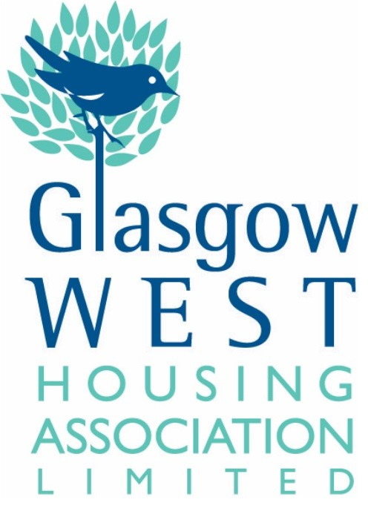

Dear Applicant

GLASGOW WEST HOUSING ASSOCIATION: SERVICES ASSISTANT

Thank you for your request for an Application Pack for the above position.

I enclose the following:

FOR COMPLETION | FOR INFORMATION
Application Form  Person Specification  Equality Monitoring Form | Role Profile  Guidance Notes  Privacy Notice

Please note that incomplete applications will not be considered and therefore it is important that you return all information for completion as noted above.

The closing date for receipt of applications is FRIDAY 10 JANUARY 2025, 12noon.
Any applications received after this time will not be considered.

The post is subject to satisfactory Disclosure.

Please return all completed documents either by email to recruitment@glasgowwestha.co.uk or by post, marked “Private and Confidential” for my attention, to Glasgow West Housing Association Limited, 5 Royal Crescent, Glasgow, G3 7SL.

Yours sincerely

N.Fairley

Nicole Fairley
HR Administrator
Enc

GUIDANCE NOTES FOR APPLICANTS
Please read these notes carefully
They are intended to help you make the best of your application.

1. The form can be emailed or posted. The form should be completed in black ink for photocopying purposes. If you return your application form by email, you will be asked to sign a copy of this form if you are invited for interview.

2. If posting your application, please ensure you pay the correct postage – this should be a Large Letter stamp if using an A4 paper sized envelope.

3. To ensure your application is considered by GWHA, please return your completed application form and your completed person specification sheet.

4. Please do not send in your Curriculum Vitae.

5. One of your references should be your present or most recent employer. If you have not been employed or have been out of employment for a long time, you should give the name of someone who knows you sufficiently well to confirm the information you have given. Please note that referees will only be contacted after interview and with your prior permission.

6. The enclosed Person Specification lists the requirements for this post. When short listing for interview, the selection panel will only consider the information contained in your application form and the Person Specification, therefore please ensure you give sufficient detail within your response to allow the panel to assess your suitability for the post.

7. It is not the responsibility of the Selection Panel to make assumptions about the nature of the work you have done from a list of job titles. It is therefore important that you use the space provided to detail your experience and skills. Neither is it enough for you just to state that you meet the requirements; you must demonstrate this to the Panel. Work, paid or voluntary, is not the only means of showing that you meet the requirements of the post. Life experience and skills are just as valid, so long as you are able to demonstrate this.

8. If you are short listed for interview, the Selection Panel will wish to discuss the areas covered in the Person Specification in more detail. In particular, your commitment to and understanding of Equality and Diversity will be assessed.

9. If you are related to any members of staff, management committee, contractors or suppliers to the Association, this should be shown clearly on the part 8 of the application form. This will not necessarily be detrimental to your application.

